S-100 – Part 50

Scripting

Page intentionally left blank
Contents

50-1 Scope 5
50-2 Conformance 5
50-3 Normative References 5
50-4 Abbreviations and Definitions 5
50-5 Purpose 6
50-6 Scripting Catalogue 6
50-6.1 Distribution 7
50-6.2 Domain Specific Catalogue Functions 7
50-7 Data Exchange 7
50-7.1 DEF Schema 8
50-7.1.1 Special Characters 8
50-7.1.2 String Encoding 8
50-7.1.3 Parsing 8
50-7.2 Attribute Path 9
50-8 Hosting Requirements 10
50-8.1 Lua Version 10
50-8.2 Character Encoding 10
50-8.3 Error Handling 10
50-8.4 Array Parameters 10
50-8.5 Host Functions 10
50-8.5.1 Compatibility 10
50-9 Standard Script Functions 11
50-9.1 Standard Catalogue Functions 12
50-9.1.1 Object Creation Functions 13
50-9.1.2 Type Information Creation Functions 23
50-9.1.3 Miscellaneous Functions 38
50-9.2 Standard Host Functions 42
50-9.2.1 Data Access Functions 42
50-9.2.2 Type Information Access Functions 58
50-9.2.3 Spatial Operations Functions 70
50-9.2.4 Debugger Support Functions 72

Page intentionally left blank

Scope
This part defines a standard mechanism for including scripting support in S-100 based products. Scripting provides for processing of S-100 based datasets via script files written in the Lua programming language.

Conformance
Scripts conforming to this part shall be implemented using version 5.1 of the Lua programming language.

Normative References
The following referenced documents are required for the application of this document. For dated references, only the edition cited applies. For undated references, the latest edition of the referenced document (including amendments) applies.
Lua 5.1 Reference Manual, https://www.lua.org/manual/5.1/
ISO 19125-1:2004, Geographic information -- Simple feature access -- Part 1: Common architecture

Abbreviations and Definitions
API – Application Programming Interface
DEF - Data Exchange Format
Domain Specific Functions – All scripting functions which are defined outside of this part. The union of Domain Specific Host Functions and Domain Specific Catalogue Functions.
Domain Specific Catalogue Functions – Scripting functions provided within a scripting catalogue which are not part of the standard catalogue functions.
Domain Specific Host Functions – Scripting functions provided by a host to support domain-specific functionalities.
ECDIS – Electronic Chart Display and Information System
Host – The environment hosting the Lua interpreter. Typically the host is an application which uses one or more S-100 based products, such as an ECDIS.
Host Functions – The scripting functions provided by a host. The union of the Standard Host Functions and the Domain Specific Host Functions.
Scripting Catalogue – Generic term describing a collection of one or more files containing scripting functions.
Scripting Domain – The application of scripting to an S-100 domain, such as portrayal.
Scripting Engine – A Lua interpreter or virtual machine.
Scripting Function – A function written in Lua.
Standard Catalogue Functions - Scripting functions which are guaranteed to be part of all scripting catalogues.
Standard Host Functions – Scripting functions which must be provided by the host. Scripting functions call standard host functions to obtain information about the dataset(s) being processed.
Standard Scripting Functions – All scripting functions defined within this part. The union of Standard Host Functions and Standard Catalogue Functions.

Purpose
This part is provided to permit the normative expression and processing of rules for S-100 based products. Possible usage examples include: portrayal rules, product interoperability rules, rules for detecting navigational hazards, data validation rules, etc.
The use of scripting removes ambiguity from rule expression, ensures consistency among applications, and allows for rules to be modified or extended via catalogue updates.

Scripting Catalogue
A scripting catalogue (see Figure 1) is a collection of script files written for use within a scripting domain.
For instance, portrayal is a scripting domain. The rule files contained within a Lua portrayal catalogue comprise a scripting catalogue.
All scripting catalogues are guaranteed to contain the standard catalogue functions defined in 50-9.1. Scripting catalogues may additionally contain domain specific catalogue functions. The standard catalogue functions simplify the creation, integration, and testing of scripts within a scripting domain.
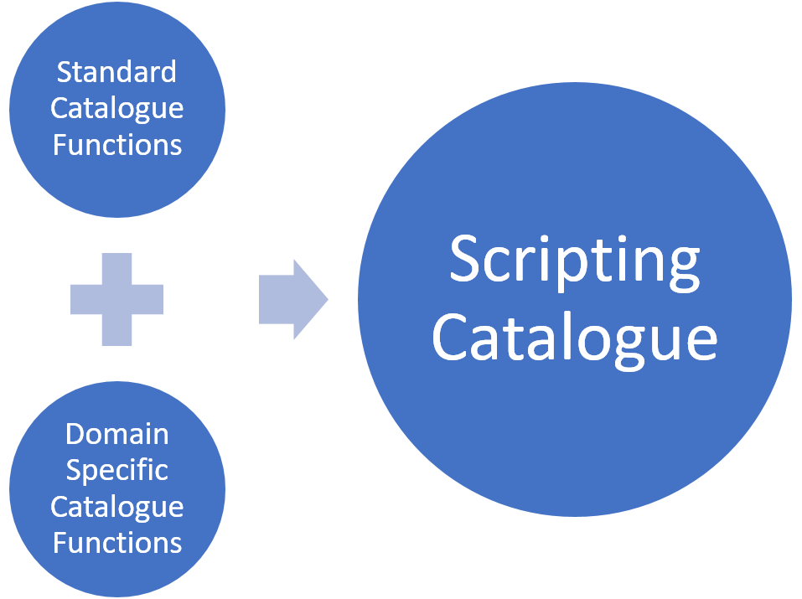
Figure 1 – Composition of a Scripting Catalogue
In order to apply rules within a scripting domain, scripting catalogues interact with host functions. The relationship between the scripting catalogue and the host functions is shown below. The host functions serve to decouple the scripting catalogue from the host’s implementation of S-100 concepts and functionalities.
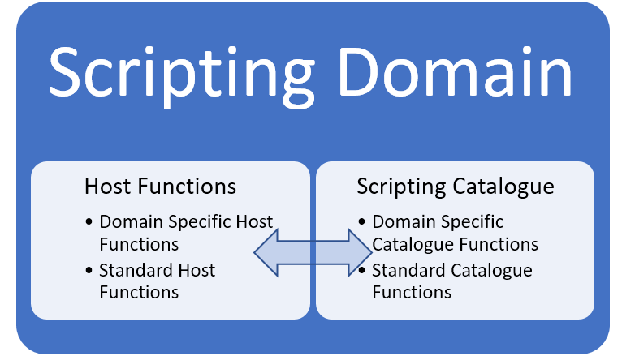
Figure 2 - Scripting Catalogue / Host interaction within a Scripting Domain

Distribution
The distribution mechanism of a scripting catalogue is defined within the scripting domain. For example, S-100 Part 9A includes a scripting catalogue within the portrayal catalogue; distribution of the scripting catalogue is accomplished via distribution of the portrayal catalogue.
Each instance of a scripting catalogue must include all standard catalogue functions.

Domain Specific Catalogue Functions
The standard scripting functions are always available within a scripting catalogue. Parts of S-100 which use scripting may provide additional scripting functions as needed to support domain-specific functionality. In this case, the additional functions are referred to as "domain specific functions".
Domain specific functions intended for host / scripting catalogue interaction (see Figure 2) must be specified within the relevant part of S-100. Domain specific functions used internally within a scripting catalogue need not be specified within S-100.
For example, assume S-100 Part N uses scripting and requires the addition of scripting functions X, Y, and Z. If functions X and Y are called from the host, but function Z is only called from functions X and Y, S-100 Part N must specify required functions X and Y, and provide the documentation for each function. Since function Z is only used internally by the scripting catalogue, it does not need to be documented.
Domain specific functions used for interaction between a host and scripting catalogue are referred to as "domain specific host functions" or "domain specific catalogue functions", depending on whether they are implemented by the host or within the scripting catalogue.

Data Exchange
Data that is passed to the host from a scripting catalogue may be retrieved using the Lua C API functions that correspond to the data type. For the simple data types such as nil, boolean, string and number, retrieval of the data is trivial. For more complex data types, the scripting catalogue encodes the data using the Data Exchange Format (DEF) described in this section.

DEF Schema
The Data Exchange Format is a string, formatted as described below. Host parsing of the DEF is simple to implement using the parsing capabilities built into all popular programming languages. Host parsing of the DEF should typically be implemented using string splitting operations such as String.split() in Java, or using simple scan parsing, such as strtok() in C or C++.
A DEF string is a series of one or more elements separated by semicolons (;). Each element is comprised of an item string, followed optionally by a colon (:) and a parameter list. A parameter list is one or more parameter strings separated by commas (,).
Note that string parameters are not surrounded by any delimiters such as quotation marks, however special characters within the string parameters will be escaped using an ampersand (&) as described in .

Special Characters
The following table lists the special characters used by the DEF.
Special Character | Usage
Semicolon (;) | Separates the individual elements of a DEF.
Colon (:) | Separates each element into an item string and a parameter list.
Comma (,) | Separates the individual parameters of a parameter list.
Ampersand (&) | Escapes / encodes special characters contained within the DEF.

String Encoding
Table 1 – Special Characters
Special characters contained within the DEF are escaped / encoded using the character sequences listed in the following table.
Special Character | Encoding
Semicolon (;) | &s
Colon (:) | &c
Comma (,) | &m
Ampersand (&) | &a
For example, a notional DEF containing four elements that might be used to represent drawing instructions:
Table 2 – String Encoding
PenWidth:0.64;PenColor:LANDF,0.75;DrawLine;DrawTextStrings:Hello&m world!,,Foo&cbar
The first element has one parameter (0.64), the second element has two parameters (LANDF and 0.75), the third element has no parameters, and the fourth element has three parameters (Hello, world!, null or empty, and Foo:bar).

Parsing
There are four steps to parsing the DEF: (1) get each element, (2) get the item and parameters for each element, (3) break the parameters into individual pieces, and then (4) decode each parameter. The notional DEF:
Item1:P1A;Item2:P2A,P2B;Item3:Hello&m world!
The host should first split the DEF into individual elements on each semicolon (;) boundary resulting in the following:

ELEMENT # | ELEMENT
1 | Item1:P1A
2 | Item2:P2A,P2B
3 | Item3:Hello&m world!

Each of the elements should then be divided into an item and the items parameter(s) by splitting on colon (:) boundaries, resulting in:
ELEMENT # | ELEMENT | ITEM | PARAMETERS
1 | Item1:P1A | Item1 | P1A
2 | Item2:P2A,P2B | Item2 | P2A,P2B
3 | Item3:Hello&m world! | Item3 | Hello&m world!

The parameters should then be individually extracted by splitting the parameters on each comma (,) boundary, resulting in:
ELEMENT # | ELEMENT | ITEM | PARAMETER 1 | PARAMETER 2 | … | PARAMETER N
1 | Item1:P1A | Item1 | P1A
2 | Item2:P2A,P2B | Item2 | P2A | P2B
3 | Item3:Hello&m world! | Item3 | Hello&m world!

Once the DEF has been divided into its constituent parts, each parameter should be converted to its original string encoding by performing the substitutions listed in :
ELEMENT # | ELEMENT | ITEM | PARAMETER 1 | PARAMETER 2 | … | PARAMETER N
1 | Item1:P1A | Item1 | P1A
2 | Item2:P2A,P2B | Item2 | P2A | P2B
3 | Item3:Hello&m world! | Item3 | Hello, world!

Attribute Path
Scripting catalogues need to be able to determine the value of the attributes on each feature instance contained within a dataset. In order to do so, a catalogue will query the host for each attribute value as needed. When querying a host, the catalogue must identify which attribute of a given feature is being queried. If a feature instance contains only simple attributes, identifying the feature instance and attribute code is sufficient for the host to uniquely identify the requested attribute.
The host requires more information when the attribute value is contained within a complex attribute. For example, consider the following attribute value lookup:
feature.sectorCharacteristic[2].lightSector[1].valueOfNominalRange
Here the feature has a complex attribute sectorCharacteristic, which is an array. The second entry of sectorCharacteristic contains the complex attribute lightSector, the first entry of which contains the simple attribute valueOfNominalRange.
When requesting the value of valueOfNominalRange, scripting must provide the host with a path to the desired attribute, in addition to the code of the desired attribute so that the host can return the actual value. The path is required because the feature instance may have multiple attribute instances with the same code contained within alternate attribute paths – e.g. feature.simpleAttribute, vs. feature.complexAttribute[n].simpleAttribute vs. feature.complexAttribute[n+1].simpleAttribute.
When the scripting catalogue requests an attribute value from the host, an attribute path is provided to the host using a DEF string. Each section of the path is encoded as an element containing the AttributeCode and Index. AttributeCode contains the code of a complex attribute; Index stores the array index of the complex attribute.
In the example above, the path to valueOfNominalRange would be expressed in DEF as follows:
sectorCharacteristic:2;lightSector:1
The DEF would be used in a call to the host from a scripting catalogue as follows:
HostFeatureGetSimpleAttribute(featureID, sectorCharacteristic:2;lightSector:1, valueOfNominalRange)

Hosting Requirements
This section defines the requirements imposed on a host in order to support scripting functionality. For example, a program written to display an S-101 chart using the S-100 Part 9A portrayal must conform to the requirements of this section.

Lua Version
The host must provide a scripting engine; a Lua version 5.1 interpreter or virtual machine. The reference implementation is available from lua.org (http://www.lua.org/). Embedding the reference implementation into the host is recommended. For maximum performance the host can embed or implement a Lua compiler such as LuaJIT (http://luajit.org/).
Further guidance on embedding is provided in Programming in Lua – Part IV (The C API), details of which are available at https://www.lua.org/pil/.

Character Encoding
All strings exchanged between the host and the scripting catalogue must be UTF-8 encoded.

Error Handling
When calling Lua scripting catalogue functions from the host, a return value of LUA_OK from lua_pcall indicates success. Otherwise, the standard Lua error handling mechanism is used. An error code is returned to the host and a string detailing the error will be available on the top of the stack.

Array Parameters
Several of the scripting catalogue functions expect arrays to be passed as parameters. The arrays are standard Lua arrays which should be created using the Lua C API array functions as documented in Programming in Lua – Part IV (The C API).

Host Functions
The host must provide the standard host functions detailed in 50-9.1.3.2.
The host must also provide domain specific host functions in order to support domain specific functionalities. Domain specific functionalities which are unused by the host do not need to be provided. Documentation for domain specific host functions is provided in the part(s) of S-100 describing the domain specific functionality.

Compatibility
The host must guarantee backwards compatibility of the host provided functions with all previously published scripting catalogues. That is, when implementing function X, the host must only call scripting catalogue functions which were available in the version of S-100 when X was added.
Failure to conform to this requirement may result in incompatibilities when the host attempts to run older scripting catalogues.

Scripting Catalogue / Host Incompatibility
As new versions of S-100 are published, scripting functions may be added. Scripting functions will never be removed from S-100, although the use of a particular function may be deprecated.
Although backwards compatibility is guaranteed, newer scripting catalogues may attempt to call host functions which are unsupported by the current host. This situation is indicative of a host which has not been updated with the latest host scripting functions. To limit the occurrence of such cases, scripting catalogues should be written using the earliest subset of scripting functions possible.
Scripting incompatibilities (missing host functions) are indicated during scripting initialization. Incompatibility is indicated to the host by returning LUA_ERRERR from lua_pcall; the error string at the top of the stack will detail the cause of the incompatibility. When this occurs the host should revert to an earlier version of the scripting catalogue if available. It is also recommended to alert the user to check for an update of the host software.

Standard Script Functions
This section describes the set of standard script functions which constitute the scripting system. There are two sets of functions described: standard catalogue functions, and standard host functions. The realization of a scripting catalogue only exists within a scripting domain.
Standard catalogue functions, as described in 50-9.1, are provided within each scripting catalogue. Standard host functions, as described in 50-9.1.3.2, are to be implemented by the program which is hosting the scripting environment.
The figure below shows the location of each type of scripting function within the scripting environment.
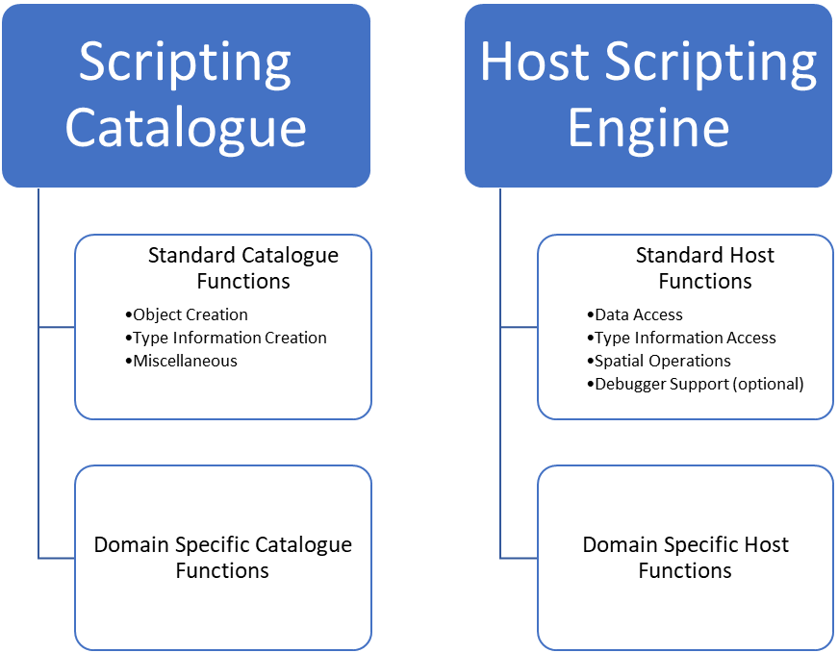
Figure 3 – Location of script functions within the scripting environment
Each standard script function is described below on its own page. A description of the functions purpose, along with a description of the parameters and return value are provided. For clarity, void is used to indicate that a function has no return value.
Function parameters which can accept multiple types will be indicated as variant. variant will also be used if the function can return more than one type. For instance, a function which accepts both integers and strings for its first parameter, and returns either an integer or string dependent on the type passed for the first parameter, would have a signature of:
variant Function(variant param1)
The function description will indicate the types which are permitted for the variant parameter(s).
Many of the standard script functions accept a featureID, informationTypeID or spatialID parameter. The host must ensure that these various ID parameters uniquely identify a single instance among all datasets across all product types to be used by the host during a scripting session. Since each type of ID is a string, one way to accomplish this is by prepending the relevant information to the ID: e.g. "S101.US3DE01M__.000.F1" to identify the first feature in the referenced S-101 dataset.

Standard Catalogue Functions
This section describes the standard set of functions which are provided by all scripting catalogues.
All strings passed to these functions must be UTF-8 encoded.
When calling these functions, attribute values are always passed from the host to the scripting environment using strings. This allows values which don’t have Lua equivalents to be passed unambiguously. This also allows for decimal values to be passed without the loss of precision which can occur during conversion to IEEE floating point types.
If an attribute value is present but unknown, the value returned from GetUnknownAttributeString() should be used.
The following table shows the string representations of the types defined by S100_CD_AttributeValueType.
S100_CD_AttributeValueType | Representation
boolean | “0” represents False  “1” represents True
enumeration | S100_FC_ListedValue:code. Do not use S100_FC_ListValue:label
integer | String representation of a signed integer.
real | String representation of a decimal number. Trailing zeros are permitted only if significant.
text | As provided.
date | Character encoding shall follow the format for date as specified by ISO 8601
time | Character encoding shall follow the format for time as specified by ISO 8601
dateTime | Character encoding shall follow the format for date and time as specified by ISO 8601
URI | Character encoding shall follow the format for URI as specified by RFC 3986
URL | Character encoding shall follow the format for URL as specified by RFC 3986
URN | Character encoding shall follow the format for URN as defined by RFC 2141
S100_CodeList | As provided.
S100_TruncatedDate | As provided.
Table 3 – String representation of types defined by S100_CD_AttributeValueType

Object Creation Functions
These functions relieve the host from the burden of constructing Lua tables corresponding to complex types used within the scripting catalogue. They allow the host to create objects which will be passed into the scripting catalogue. The schema and contents of the created objects are opaque to the host – they are only intended for use within the scripting catalogue.

SpatialAssociation CreateSpatialAssociation(string spatialType, string spatialID, string orientation, variant scaleMinimum, variant scaleMaximum)
Return Value
SpatialAssociation
A Lua table containing a spatial association object.
Parameters
spatialType: string
The type of the spatial. One of: "Point", "MultiPoint", "Curve", "CompositeCurve", or "Surface".
spatialID: string
Used by the host to uniquely identify a spatial.
orientation: string
Orientation of the spatial. One of Forward or Reverse.
scaleMinimum: integer or nil
Minimum display scale for the spatial or nil.
scaleMaximum: integer or nil
Maximum display scale for the spatial or nil.
Remarks
Called from the host to create a spatial association for use by the scripting catalogue.
It is not intended that the host manipulate the returned object; the object is intended to be passed from the host back to the scripting catalogue.

Point CreatePoint(string x, string y, variant z)
Return Value
Point
A Lua table containing a point object.
Parameters
x: string
X coordinate for the point.
y: string
Y coordinate for the point.
z: string or nil
Z coordinate for the point. For 2D points, this value shall be nil.
Remarks
x, y and z are expressed using the real string representation as described in section 50-9.1
Called from the host to create a point spatial object for use by the scripting catalogue.
It is not intended that the host manipulate the returned object; the object is intended to be passed from the host back to the scripting catalogue.

MultiPoint CreateMultiPoint(Point[] points)
Return Value
MultiPoint
A Lua table containing a multipoint object.
Parameters
points: Point[]
A Lua array of points. The host creates each point by calling CreatePoint.
Remarks
Called from the host to create a multipoint spatial object for use by the scripting catalogue.
It is not intended that the host manipulate the returned object; the object is intended to be passed from the host back to the scripting catalogue.

CurveSegment CreateCurveSegment(Point[] controlPoints, string interpolation)
Return Value
CurveSegment
A Lua table containing a curve segment object.
Parameters
controlPoints: Point[]
Array of points that define the control points of the curve segment. The host creates each controlPoint by calling CreatePoint.
interpolation: string
The interpolation to use when connecting the control points. One of S100_CurveInterpolationL:name.
Remarks
Called from the host to create a curve segment spatial object.
It is not intended that the host manipulate the returned object; the object is intended to be passed from the host back to the scripting catalogue.

Curve CreateCurve(Point startPoint, Point endPoint, CurveSegment[] segments)
Return Value
Curve
A Lua table containing a curve object.
Parameters
startPoint: Point
Start point for the curve. Host creates by calling CreatePoint.
endPoint: Point
End point for the curve. Host creates by calling CreatePoint.
segments: CurveSegment[]
An array of curve segments comprising the curve. Each array entry is created by calling CreateCurveSegment.
Remarks
Called from the host to create a curve spatial object.
It is not intended that the host manipulate the returned object; the object is intended to be passed from the host back to the scripting catalogue.

CompositeCurve CreateCompositeCurve(SpatialAssociation[] curveAssociations)
Return Value
CompositeCurve
A Lua table containing a composite curve object.
Parameters
curveAssociations: SpatialAssociation[]
Array of spatial associations that define the elements of the composite curve. The host creates each SpatialAssociation by calling CreateSpatialAssociation.
Remarks
Called from the host to create a composite curve spatial object.
It is not intended that the host manipulate the returned object; the object is intended to be passed from the host back to the scripting catalogue.

Surface CreateSurface(SpatialAssociation exteriorRing, variant interiorRings)
Return Value
Surface
A Lua table containing a surface object.
Parameters
exteriorRing: SpatialAssociation
The spatial association of the ring that defines the exterior ring of the surface. Host creates by calling CreateSpatialAssociation.
interiorRings: SpatialAssociation[] or nil
Defines the "holes" within the surface. Host creates each interior ring by calling CreateSpatialAssociation. If there are no holes, this parameter is nil.
Remarks
Called from the host to create a surface spatial object.
It is not intended that the host manipulate the returned object; the object is intended to be passed from the host back to the scripting catalogue.

ArcByCenterPoint CreateArcByCenterPoint(SpatialAssociation centerPoint, real radius, real startAngle, real angularDistance)
Return Value
ArcByCenterPoint
A Lua table containing an ArcByCenterPoint object.
Parameters
centerPoint: SpatialAssociation
The spatial association of the point that defines the centre point of the arc. Host creates by calling CreateSpatialAssociation.
radius: real
Defines the geodesic distance from the centre.
startAngle: real
Starting bearing of the arc in degrees, range limited to [0.0, 360.0].
angularDistance: real
Angular distance of the arc in degrees, range limited to [-360.0, 360.0]. Positive numbers indicate a clockwise direction.
Remarks
Called from the host to create an ArcByCenterPoint spatial object. The arc starts at the bearing given by the startAngle parameter and ends at the bearing calculated by adding the value of the angularDistance parameter to the start angle. The direction of the arc is given by the sign of the angular distance. Bearings are relative to true north except that arcs centred at either pole (where true north is undefined or ambiguous) shall use the prime meridian as the reference direction.

It is not intended that the host manipulate the returned object; the object is intended to be passed from the host back to the scripting catalogue.

CircleByCenterPoint CreateCircleByCenterPoint(SpatialAssociation centerPoint, real radius, real startAngle, real angularDistance)
Return Value
CircleByCenterPoint
A Lua table containing a CircleByCenterPoint object.
Parameters
centerPoint: SpatialAssociation
The spatial association of the point that defines the centre point of the circle. Host creates by calling CreateSpatialAssociation.
radius: real
Defines the geodesic distance from the centre.
startAngle: real
Optional. Starting bearing of the arc in degrees, range limited to [0.0, 360.0]. Default is zero.
angularDistance: real
Optional. Angular distance of the circle in degrees, must be either -360.0 (counter-clockwise) or 360.0 (clockwise). Positive numbers indicate a clockwise direction. Default is 360 (clockwise).
Remarks
Called from the host to create a CircleByCenterPoint object.
It is not intended that the host manipulate the returned object; the object is intended to be passed from the host back to the scripting catalogue.

Type Information Creation Functions
These functions relieve the host from the burden of constructing Lua tables corresponding to complex types used within the scripting catalogue. They allow the host to create objects used when calling into the scripting catalogue. The schema and contents of the created objects are opaque to the host – they are only intended for use within the scripting catalogue.
The complex types correspond to the classes described in S-100 Part 5 - Feature Catalogue. Each type information creation function described in this section specifies the corresponding S-100 Part 5 feature catalogue type.
Creation functions for FC_DefinitionReference and its dependent types, including the CI_Citation class, are intentionally omitted. There are no identified use cases for FC_DefinitionReference, and the implementation of CI_Citation would be more complicated than the entirety of this section as currently defined.

Item CreateItem(string code, string name, string definition, string remarks, string[] alias)
Return Value
Item
A Lua table containing an item corresponding to an S100_FC_Item.
Parameters
code: string
Code that uniquely identifies the named type within the feature catalogue.
name: string
Name of the item.
definition: string
Definition of the named type in a natural language.
remarks: string
Optional. Further explanation about the item.
alias: string[]
Equivalent name(s) of this item.
Remarks
Called from the host to create an item.
It is not intended that the host manipulate the returned object; the object is intended to be passed from the host back to the scripting catalogue.

NamedType CreateNamedType(Item item, boolean abstract, AttributeBinding[] attributeBindings)
Return Value
NamedType
A Lua table containing a named type corresponding to an S100_FC_NamedType.
Parameters
item: Item
Instance of an item created by calling CreateItem(). Alternatively, the parameters to the CreateItem() function can be substituted for the single item parameter.
abstract: boolean
Indicates if instances of this named type can exist in a geographic data set. Abstract types cannot be instantiated but serve as base classes for other (non-abstract) types.
attributeBindings: AttributeBinding[]
An array of zero or more bindings to attributes which describe the characteristic of this named type.
Remarks
Called from the host to create a named type.
It is not intended that the host manipulate the returned object; the object is intended to be passed from the host back to the scripting catalogue.

ObjectType CreateObjectType(NamedType namedType, InformationBinding[] informationBindings)
Return Value
ObjectType
A Lua table containing an object type corresponding to an S100_FC_ObjectType.
Parameters
namedType: NamedType
Instance of a named type created by calling CreateNamedType(). Alternatively, the parameters to the CreateNamedType() function can be substituted for the single namedType parameter.
informationBindings: InformationBinding[]
An array of zero or more bindings to information types that can be associated to this object type by means of an information association.
Remarks
Called from the host to create an object type.
It is not intended that the host manipulate the returned object; the object is intended to be passed from the host back to the scripting catalogue.

InformationType CreateInformationType(NamedType namedType, InformationType superType, InformationType[] subType)
Return Value
InformationType
A Lua table containing an information type corresponding to an S100_FC_InformationType.
Parameters
namedType: NamedType
Instance of a named type created by calling CreateNamedType(). Alternatively, the parameters to the CreateNamedType() function can be substituted for the single namedType parameter.
superType: InformationType
Optional. Indicates the information type from which this type is derived.
subType: InformationType[]
An array of zero or more information types which are derived from this type.
Remarks
Called from the host to create an information type.
It is not intended that the host manipulate the returned object; the object is intended to be passed from the host back to the scripting catalogue.

FeatureType CreateFeatureType(NamedType namedType, string featureUseType, string[] permittedPrimitives, FeatureBinding[] featureBindings, FeatureType superType, FeatureType[] subType)
Return Value
FeatureType
A Lua table containing a feature type corresponding to an S100_FC_FeatureType.
Parameters
namedType: NamedType
Instance of a named type created by calling CreateNamedType(). Alternatively, the parameters to the CreateNamedType() function can be substituted for the single namedType parameter.
featureUseType: string
A S100_CD_FeatureUseType:Name.
permittedPrimitives: string[]
An array specifying zero or more allowed spatial primitive types for the feature type. Each entry is a S100_FC_SpatialPrimitiveType:Name.
featureBindings: FeatureBinding[]
An array of zero or more bindings to feature types that can be related to this feature type by means of a feature association.
superType: FeatureType
Optional. Indicates the feature type from which this type is derived. The sub-type will inherit all properties from its super-type: Name, definition and code will usually be overridden by the sub-type, although new properties may be added to the sub-type.
subType: FeatureType[]
An array of zero or more feature types which are derived from this type.
Remarks
Called from the host to create a feature type.
It is not intended that the host manipulate the returned object; the object is intended to be passed from the host back to the scripting catalogue.

InformationAssociation CreateInformationAssociation(NamedType namedType, Role[] roles, InformationAssociation superType, InformationAssociation[] subType)
Return Value
InformationAssociation
A Lua table containing an information association corresponding to an S100_FC_InformationAssociation.
Parameters
namedType: NamedType
Instance of a named type created by calling CreateNamedType(). Alternatively, the parameters to the CreateNamedType() function can be substituted for the single namedType parameter.
roles: Role[]
An array of zero to two roles of the association.
superType: InformationAssociation
Optional. Indicates the information association from which this association is derived.
subType: InformationAssociation[]
An array of zero or more information associations which are derived from this association.
Remarks
Called from the host to create an information association.
It is not intended that the host manipulate the returned object; the object is intended to be passed from the host back to the scripting catalogue.

FeatureAssociation CreateFeatureAssociation(NamedType namedType, Role[] roles, FeatureAssociation superType, FeatureAssociation[] subType)
Return Value
FeatureAssociation
A Lua table containing a feature association corresponding to an S100_FC_FeatureAssociation.
Parameters
namedType: NamedType
Instance of a named type created by calling CreateNamedType(). Alternatively, the parameters to the CreateNamedType() function can be substituted for the single namedType parameter.
roles: Role[]
An array of zero to two roles of the association.
superType: FeatureAssociation
Optional. Indicates the feature association from which this association is derived.
subType: FeatureAssociation[]
An array of zero or more feature associations which are derived from this association.
Remarks
Called from the host to create a feature association.
It is not intended that the host manipulate the returned object; the object is intended to be passed from the host back to the scripting catalogue.

Role CreateRole(Item item)
Return Value
Role
A Lua table containing a role corresponding to a S100_FC_Role.
Parameters
item: Item
Instance of an item created by calling CreateItem(). Alternatively, the parameters to the CreateItem() function can be substituted for the single item parameter.
Remarks
Called from the host to create a role.
It is not intended that the host manipulate the returned object; the object is intended to be passed from the host back to the scripting catalogue.

SimpleAttribute CreateSimpleAttribute(Item item, string valueType, string uom, string quantitySpecification, AttributeConstraints attributeContraints, ListedValue[] listedValues)
Return Value
SimpleAttribute
A Lua table containing a simple attribute corresponding to a S100_FC_SimpleAttribute.
Parameters
item: string
Instance of an item created by calling CreateItem(). Alternatively, the parameters to the CreateItem() function can be substituted for the single item parameter.
valueType: string
The value type of this feature attribute. A S100_CD_AttributeValueType:Name.
uom: string
Optional. Unit of measure used for values of this feature attribute. A S100_UnitOfMeasure:Name.
quantitySpecification: string
Optional. Specification of the quantity. A S100_CD_QuantitySpecification:Name.
attributeContraints: AttributeConstraints
Optional. Constraints which may apply to the attribute. Created by calling CreateAttributeConstraints().
listedValues: ListedValue[]
Array of zero or more listed values for an enumerated attribute domain. Each listed value is created by calling CreateListedValue(). Applies only if valueType is Enumeration or S100_Codelist (with codelistType of open enumeration).
Remarks
Called from the host to create a simple attribute type info object.
It is not intended that the host manipulate the returned object; the object is intended to be passed from the host back to the scripting catalogue.

ComplexAttribute CreateComplexAttribute(Item item, AttributeBinding[] subAttributeBindings)
Return Value
ComplexAttribute
A Lua table containing a complex attribute corresponding to a S100_FC_ComplexAttribute.
Parameters
item: string
Instance of an item created by calling CreateItem(). Alternatively, the parameters to the CreateItem() function can be substituted for the single item parameter.
subAttributeBindings: AttributeBinding[]
An array of one or more of attribute bindings to the sub-attributes.
Remarks
Called from the host to create a complex attribute type info object.
It is not intended that the host manipulate the returned object; the object is intended to be passed from the host back to the scripting catalogue.

ListedValue CreateListedValue(string label, string definition, integer code, string remarks, string[] aliases)
Return Value
ListedValue
A Lua table containing a listed value corresponding to an S100_FC_ListedValue.
Parameters
label: string
Descriptive label that uniquely identifies one value of the feature attribute.
definition: string
Definition of the listed value in a natural language.
code: integer
Numeric code that uniquely identifies the listed value for the corresponding feature attribute. Positive integer.
remarks: string
Optional. Further explanation about the listed value.
aliases: string[]
Optional. Array of zero or more equivalent name(s) of this listed value.
Remarks
Called from the host to create a listed value type info object.
It is not intended that the host manipulate the returned object; the object is intended to be passed from the host back to the scripting catalogue.

AttributeBinding CreateAttributeBinding(string attributeCode, integer lowerMultiplicity, integer upperMultiplicity, boolean sequential, integer[] permittedValues)
Return Value
AttributeBinding
A Lua table containing an attribute binding corresponding to an S100_FC_AttributeBinding.
Parameters
attributeCode: string
The code of the complex or simple attribute that is bound to the item or complex attribute.
lowerMultiplicity: integer
The minimum number of required occurrences of this attribute. This is zero for optional attributes.
upperMultiplicity: integer
The maximum number of allowed occurrences of this attribute. This is nil for an infinite number of allowed attributes.
sequential: boolean
Describes if the sequence of the attributes is meaningful or not. Applies only to attributes which may occur more than once.
permittedValues: integer[]
Array of zero or more permissible values of the attribute. Each entry is a S100_FC_ListedValue:code. Applies only to attributes of data type enumeration.
Remarks
Called from the host to create an attribute binding object.
It is not intended that the host manipulate the returned object; the object is intended to be passed from the host back to the scripting catalogue.

InformationBinding CreateInformationBinding(string informationTypeCode, integer lowerMultiplicity, integer upperMultiplicity, string roleType, Role role, InformationAssociation association)
Return Value
InformationBinding
A Lua table containing an information binding corresponding to a S100_FC_InformationBinding.
Parameters
informationTypeCode: string
The S100_FC_InformationType:code of the target information type.
lowerMultiplicity: integer
The minimum number of required occurrences of this attribute. This is zero for optional attributes.
upperMultiplicity: integer
The maximum number of allowed occurrences of this attribute. This is nil for an infinite number of allowed attributes.
roleType: string
The nature of the association end. A S100_FC_RoleType:Name.
role: Role
Optional. The role used for the binding. It must be part of the association used for the binding and defines the end of the association.
association: InformationAssociation
The association used for the binding; defining also the role.
Remarks
Called from the host to create an information binding object.
It is not intended that the host manipulate the returned object; the object is intended to be passed from the host back to the scripting catalogue.

FeatureBinding CreateFeatureBinding(string featureTypeCode, integer lowerMultiplicity, integer upperMultiplicity, string roleType, Role role, FeatureAssociation association)
Return Value
FeatureBinding
A Lua table containing a feature binding corresponding to a S100_FC_FeatureBinding.
Parameters
featureTypeCode: string
The code of the target feature type.
lowerMultiplicity: integer
The minimum number of required occurrences of this attribute. This is zero for optional attributes.
upperMultiplicity: integer
The maximum number of allowed occurrences of this attribute. This is nil for an infinite number of allowed attributes.
roleType: string
The nature of the association end. A S100_FC_RoleType:Name.
role: Role
The role used for the binding. It must be part of the association used for the binding and defines the end of the association.
association: FeatureAssociation
The association used for the binding.
Remarks
Called from the host to create a feature binding object.
It is not intended that the host manipulate the returned object; the object is intended to be passed from the host back to the scripting catalogue.

Miscellaneous Functions
The functions described on the following pages do not fall under one of the previously described functionalities.

string GetUnknownAttributeString()
Return Value
string
A string that represents an attribute value that is present but unknown.
Remarks
Intended to permit differentiation of unknown string values from empty string values. This function returns a constant value.

string EncodeDEFString(string input)
Return Value
string
An encoding of input as described in section 50-7.1.2.
Parameters
input: string
The unencoded string.
Remarks
Encodes the input string as described in section 50-7.1.2.

string DecodeDEFString(string encodedString)
Return Value
string
A decoded version of encodedString.
Parameters
encodedString: string
The encoded string.
Remarks
Decodes an input string which was previously encoded as described in section 50-7.1.2.

Standard Host Functions
The host must provide a set of "callback" functions that provide the scripting environment with: access to the host’s realization of the S-100 General Feature Model, access to type information for any entity defined by the model, and access to spatial operations which can be used to perform relational tests and operations on spatial elements defined by the model. The host may optionally provide a callback function used to interact with a debugger.
Offloading these tasks to the host, rather than providing rigid data structures which are passed between the host and scripting, allows the host to interact with scripting using the hosts optimal representation of the General Feature Model. Host translation of its internal data model to a particular input schema is not necessary when using scripting.
Any of the standard host functions may be called from the scripting catalogue during the execution of a script.

Data Access Functions
The host must implement the functions described on the following pages to allow the scripting environment to access data the host has loaded from a dataset. These functions provide the scripting environment with access to features, spatials, attribute values, and information associations.

string[] HostGetFeatureIDs()
Return Value
string[]
A Lua array containing all of the feature IDs in the dataset.
Remarks
Instructs the host to return all feature IDs relevant to the current scripting catalogue operation. This would typically be all of the features in an S100_Dataset or S100_DataCoverage.
As discussed in 50-9, the host is responsible for ensuring each feature ID uniquely identifies a single feature instance among all product types and datasets to be used during the current scripting session.

string HostFeatureGetCode(string featureID)
Return Value
string
The code defined by the feature catalogue for the feature type of the feature instance.
Parameters
featureID: string
Used by the host to uniquely identify a feature instance.
Remarks
Instructs the host to return the feature type code for the feature instance identified by featureID.

string[] HostGetInformationTypeIDs()
Return Value
string[]
A Lua array containing all of the information type IDs in the dataset.
Remarks
Allows scripts to query the host for a list of information types contained within a given dataset.
Instructs the host to return an array containing all information IDs in the given dataset.

string HostInformationTypeGetCode(string informationTypeID)
Return Value
string
The code defined by the feature catalogue for the information type of the information type instance.
Parameters
informationTypeID: string
Used by the host to uniquely identify an information type instance.
Remarks
Instructs the host to return the information type code for the information type instance identified by informationTypeID.

string[] HostFeatureGetSimpleAttribute(string featureID, path path, string attributeCode)
Return Value
string[]
The textual representation of each attribute value, as described in section 50-9.1. An array is returned even if the attribute has a single value.
Parameters
featureID: string
Used by the host to uniquely identify a feature instance.
path: path
An attribute path as described in section 50-7.2
attributeCode: string
One of the attribute codes defined in the feature catalogue for the feature type identified by featureID.
Remarks
Instructs the host to perform a simple attribute lookup on the attribute attributeCode at the path path for the feature instance identified by featureID. An empty array is returned if the requested attribute is not present.

integer HostFeatureGetComplexAttributeCount(string featureID, path path, string attributeCode)
Return Value
integer
The number of matching complex attributes that exist at the path for the feature instance.
Parameters
featureID: string
Used by the host to uniquely identify a feature instance.
path: path
An attribute path as described in section 50-7.2.
attributeCode: string
One of the attribute codes defined in the feature catalogue for the feature type identified by featureID.
Remarks
Instructs the host to return the number of attributes matching attributeCode at the given attribute path for the given feature instance. The given path will always be valid for the feature instance. The returned integer can be zero.

SpatialAssociation[] HostFeatureGetSpatialAssociations(string featureID)
Return Value
SpatialAssociation[]
A Lua array containing all of the spatial associations for the feature instance represented by featureID.
Parameters
featureID: string
Used by the host to uniquely identify a feature instance.
Remarks
Instructs the host to return an array containing the spatial associations for the given feature instance. For each spatial association the feature contains, the host calls the standard catalogue function CreateSpatialAssociation to create the SpatialAssociation object.
The host should return an empty array if the feature has no spatial associations.

variant HostFeatureGetAssociatedFeatureIDs(string featureID, string associationCode, variant roleCode)
Return Value
nil
The feature association is not valid for this feature.
string[]
A Lua array containing the associated features IDs.
Parameters
featureID: string
Used by the host to uniquely identify a feature instance.
associationCode: string
Code for requested association as defined by the feature catalogue.

roleCode: string or nil
Code for requested role as defined by the feature catalogue. Can be nil if associationCode by itself is enough to specify the association or if all roles defined by associationCode are desired.
Remarks
When called, the host returns an array containing the feature IDs associated with the given feature instance that match associationCode and roleCode. If the feature association is not valid for this feature according to the feature catalogue, the host returns nil. If no matches are found the host returns an empty array.
The roleCode may be nil, in which case only the associationCode should be used for lookup.

variant HostFeatureGetAssociatedInformationIDs(string featureID, string associationCode, variant roleCode)
Return Value
nil
The information association is not valid for this feature.
string[]
A Lua array containing the associated information IDs.
Parameters
featureID: string
Used by the host to uniquely identify a feature instance.
associationCode: string
Code for requested association as defined by the feature catalogue.
roleCode: string or nil
Code for requested role as defined by the feature catalogue. Can be nil if associationCode by itself is enough to specify the association or if all roles defined by associationCode are desired.
Remarks
When called, the host returns an array containing the information IDs associated with the given feature instance that match associationCode and roleCode. If the information association is not valid for this feature according to the feature catalogue, the host returns nil. If no matches are found the host returns an empty array.
The roleCode may be nil, in which case only the associationCode is used for lookup.

string[] HostGetSpatialIDs()
Return Value
string[]
A Lua array containing all of the spatial IDs in the dataset.
Remarks
Instructs the host to return all spatial IDs relevant to the current scripting catalogue operation. This would typically be all of the spatial objects in an S100_Dataset or S100_DataCoverage.
As discussed in 50-9, the host is responsible for ensuring each spatial ID uniquely identifies a single spatial instance among all product types and datasets to be used during the current scripting session.

Spatial HostGetSpatial(string spatialID)
Return Value
Spatial
A spatial object created via a standard catalogue function as listed in the remarks.
Parameters
spatialID: string
Used by the host to uniquely identify a spatial.
Remarks
Queries the host for a given spatial.
The host returns a spatial object created by one of the standard catalogue functions defined in 50-9.1.1.

variant HostSpatialGetAssociatedInformationIDs(string spatialID, string associationCode, variant roleCode)
Return Value
nil
The information association is not valid for this spatial.
string[]
A Lua array containing the associated information IDs.
Parameters
spatialID: string
Used by the host to uniquely identify a spatial.
associationCode: string
Code for requested association as defined by the feature catalogue.
roleCode: string or nil
Code for requested role as defined by the feature catalogue. Can be nil if associationCode by itself is enough to specify the association or if all roles defined by associationCode are desired.
Remarks
When called, the host returns an array containing the information IDs for the given spatial instance that match associationCode and roleCode. If the information association is not valid for this feature according to the feature catalogue, the host returns nil. If no matches are found the host returns an empty array.
The roleCode may be nil, in which case only the associationCode is used for lookup.

string[] HostSpatialGetAssociatedFeatureIDs(string spatialID)
Return Value
string[]
A Lua array containing the requested associated feature IDs for the spatial identified by spatialID.
nil
No features are associated to the spatial identified by spatialID.
Parameters
spatialID: string
Used by the host to uniquely identify a spatial.
Remarks
When called, the host returns an array of all feature instances that reference the given spatial. A feature instance is considered to be associated to a spatial either directly through the spatial associations on the feature, or indirectly in the case of curves referenced by composite curves.

string[] HostInformationTypeGetSimpleAttribute(string informationTypeID, path path, string attributeCode)
Return Value
string[] or nil
The textual representation of each attribute value, as described in section 50-9.1. An array is returned even if the attribute has a single value. The host should return nil if the requested attribute is not present.
Parameters
informationTypeID: string
Used by the host to uniquely identify an information instance.
path: path
An attribute path as defined in section 50-7.2.
attributeCode: string
One of the attribute codes defined in the feature catalogue for the information type identified by informationTypeID.
Remarks
Instructs the host to perform a simple attribute lookup on the attribute attributeCode at the indicated path for the information instance identified by informationTypeID. Nil is returned if the requested attribute is not present.

integer HostInformationTypeGetComplexAttributeCount(string informationTypeID, path path, string attributeCode)
Return Value
integer
The number of matching complex attributes that exist at the path for the information instance.
Parameters
featureID: string
Used by the host to uniquely identify an information instance.
path: path
An attribute path as described in section 50-7.2.
attributeCode: string
One of the attribute codes defined in the feature catalogue for the information type identified by informationTypeID.
Remarks
Instructs the host to return the number of attributes matching attributeCode at the given attribute path for the given information instance. The given path will always be valid for the information instance. The returned integer can be zero.

Type Information Access Functions
These functions allow the scripting environment to query the type information for any entity from any dataset. The type information provided by the host must match the information from the relevant feature catalogue.

string[] HostGetFeatureTypeCodes()
Return Value
string[]
Array containing all feature type codes as defined in the feature catalogue.
Remarks

string[] HostGetInformationTypeCodes()
Return Value
string[]
Array containing all information type codes as defined in the feature catalogue.
Remarks

string[] HostGetSimpleAttributeTypeCodes()
Return Value
string[]
Array containing all simple attribute type codes as defined in the feature catalogue.
Remarks

string[] HostGetComplexAttributeTypeCodes()
Return Value
string[]
Array containing all complex attribute type codes as defined in the feature catalogue.
Remarks

string[] HostGetRoleTypeCodes()
Return Value
string[]
Array containing all role type codes as defined in the feature catalogue.
Remarks

string[] HostGetInformationAssociationTypeCodes()
Return Value
string[]
Array containing all information association type codes as defined in the feature catalogue.
Remarks

string[] HostGetFeatureAssociationTypeCodes()
Return Value
string[]
Array containing all feature association type codes as defined in the feature catalogue.
Remarks

FeatureType HostGetFeatureTypeInfo(string featureCode)
Return Value
FeatureTypeInfo
Lua data structure created by the CreateFeatureType() function.
Parameters
featureCode: string
Feature code matching an entry in the feature catalogue.
Remarks

InformationType HostGetInformationTypeInfo(string informationCode)
Return Value
InformationTypeInfo
Lua data structure created by the CreateInformationType() function.
Parameters
informationCode: string
Information code matching an entry in the feature catalogue.
Remarks

SimpleAttribute HostGetSimpleAttributeTypeInfo(string attributeCode)
Return Value
SimpleAttributeTypeInfo
Lua data structure created by the CreateSimpleAttribute() function.
Parameters
attributeCode: string
Simple attribute code matching an entry in the feature catalogue.
Remarks

ComplexAttribute HostGetComplexAttributeTypeInfo(string attributeCode)
Return Value
ComplexAttributeTypeInfo
Lua data structure created by the CreateComplexAttribute() function.
Parameters
attributeCode: string
Complex attribute code matching an entry in the feature catalogue.
Remarks

Spatial Operations Functions
These functions allow the scripting environment to perform relational tests and operations on spatial elements.
The host must implement the functions described on the following pages to provide the scripting environment with the ability to relate spatial entities to one another.

boolean HostSpatialRelate(string spatialID1, string spatialID2, string intersectionPatternMatrix)
Return Value
boolean
Returns true if the geometries represented by the two spatials are related as specified in the DE-9IM matrix.
Parameters
spatialID1: string
Used by the host to uniquely identify a spatial instance.
spatialID2: string
Used by the host to uniquely identify a spatial instance.
intersectionPatternMatrix: string
DE-9IM intersection matrix expressed as nine characters in row major order. E.g. when testing for overlap between two areas: “T*T***T**”
Remarks
Spatially relates the geometries represented by spatialID1 and spatialID2 using the DE-9IM intersection specified via the intersectionPatternMatrix string.
For details on DE-9IM string representation refer to ISO 19125-1:2004, Geographic information -- Simple feature access -- Part 1: Common architecture, section 6.1.14.2 The Dimensionally Extended Nine-Intersection Model (DE-9IM).

Debugger Support Functions
These functions allow the scripting environment to interact with a debugger which may be running on the host. A debugger may be desired as an aide in developing the required standard host functions.
Host implementation of the debugger support functions is optional. Scripts will execute normally regardless of whether the host implements these functions.

void HostDebuggerEntry(string debugAction, string message)
Return Value
None
Parameters
debugAction: string
Indicates the requested debugger action:
break – Pause execution of the script.
trace – Display a string in the debugging console.
start_profiler – Begin line by line profiling of the script code.
stop_profiler – Stop line by line profiling of the script code.
message: string
Message to display on the debugging console. This is optional for all debug actions except trace, where it is mandatory.
Remarks
Host implementation of this function is optional.

